**COVID-19 and AI-Adopting Firms: A Comparative Study of Stock Performance in Large vs. Small Cap Companies**

By

Abhik Shrestha, Anisha Choudhury, Chen Yu, and Gavin Shang

ECON-314 Empirical Finance

Final Report

May 5th, 2025

**1. Introduction**

**(a) Motivation**

The COVID-19 pandemic fundamentally reshaped the global economy, accelerating technological innovation across industries. One particularly notable development has been the rapid adoption of Artificial Intelligence (AI) tools and systems. In this context, we explore a pressing research question: **Did small-cap semiconductor firms adopting AI outperform large-cap counterparts during the COVID-19 shock?** This question is vital not only for understanding firm resilience during market turbulence but also for shedding light on how technological adoption influences financial performance. From an investment perspective, insights into how firm size interacts with AI adoption under extreme events can guide strategic asset allocation. Academically, this research contributes to discussions about firm-specific risk factors and the broader implications of technological shifts on corporate valuation.

**Defining AI-Adopted Companies**

In this study, we define 'AI-adopted firms' as companies operating in sectors where *AI forms an essential component of their products, services, or operational strategies.* Our classification is based on companies' official public disclosures, such as company descriptions, earnings reports, and product announcements, where AI-related initiatives are explicitly mentioned. For instance, firms like AMD highlight its AI accelerators and GPU technologies; Intel showcases edge AI deployments and AI-specific chip innovations such as the Gaudi3 processor. Similarly, smaller firms like Magnachip Semiconductor have introduced power chips optimized for AI applications in consumer electronics.

**(b) Data and Methods**

We selected **6** semiconductor firms publicly recognized for their AI adoption. Large-cap firms include Advanced Micro Devices (AMD), Intel Corporation (INTC), and Qualcomm Incorporated (QCOM). Small-cap firms include Alpha and Omega Semiconductor (AOSL), Magnachip Semiconductor Corp (MX), and Wolfspeed, Inc. (WOLF). We classified them based on market capitalization:

* Large Market Cap: Range- $85.08 billion - $152.55 billion
* Small Market Cap: Range- $110.28 million - $479.76 million

**Timeline**: Our study period spans three key phases: pre-COVID (January 2018 – December 2019), during COVID (January 2020 – June 2021), and post-COVID (July 2021 – December 2022).

We applied Capital Asset Pricing Model (**CAPM**) and the **Fama-French 5-factor** model, to analyze market sensitivity and returns.

**(c) Results and Conclusions** During the **pre-COVID** period, large cap AI-adopting firms exhibited characteristics typical of high-growth technology stocks, with high market sensitivity and strong momentum exposure.

**During COVID**, large-cap firms demonstrated greater resilience, maintaining moderate volatility and relatively stable returns. Meanwhile, small-cap firms displayed higher volatility and mixed performance, with occasional outperformance during periods of rapid technological shifts or pandemic-driven demand spikes. Overall, the CAPM model reflected that while small-cap firms presented higher risk and higher reward characteristics, large-cap firms offered more stability throughout the pandemic. The Fama French models reflected that in terms of factors such as profitability and positive SMB exposure, small cap companies tended to outperform large cap companies during the pandemic.

**2. Data and Methods**

This study analyzes the financial performance and risk profile of the **6 companies across three distinct periods** using asset pricing models implemented in R. The analysis draws on concepts covered in class and homework to develop functions that calculate stock returns, estimate model coefficients, and compute beta values.

*For example,* when computing the model for AMD, our data sources were:

* Daily stock price data for AMD was sourced via the quantmod package from Yahoo Finance.
* Market Returns: Daily returns of the S&P 500 index (ticker ^GSPC) were used as a proxy for market returns.
* Factor Returns: Monthly Fama-French 5-Factor data and the Momentum factor were imported from CSV files.

**Methodology:**

* Daily Return Calculation: A function *dret()* computes daily log returns from adjusted closing prices.
* Monthly Return Aggregation and Factor Merging: Daily returns were aggregated into monthly log returns. These monthly returns were merged with the Fama-French and momentum factor datasets for further modeling.
* To directly estimate beta, a refined return function *dretplus()* is used to generate daily log returns over a specified period.
* Using a function called *PricingModel*, we automated the retrieval and processing of stock price data and integrated it with established asset pricing models.

*Model:*

* CAPM: A simple linear regression was performed using the market excess return (MKT-RF) as the independent variable and the stock’s excess return (monthly log return minus risk-free rate) as the dependent variable.
* Fama-French 5-Factor Model: A multivariate linear regression was run using the five Fama-French factors (MKT-RF, SMB, HML, RMW, CMA) as predictors for the stock’s excess return.

**3. Results**

**PART 1: AMD vs AOSL**

1. Advanced Micro Devices, Inc (AMD) - Larger 139.42 billion
2. Alpha and Omega Semiconductor Limited (AOSL) - Small 479.76 million

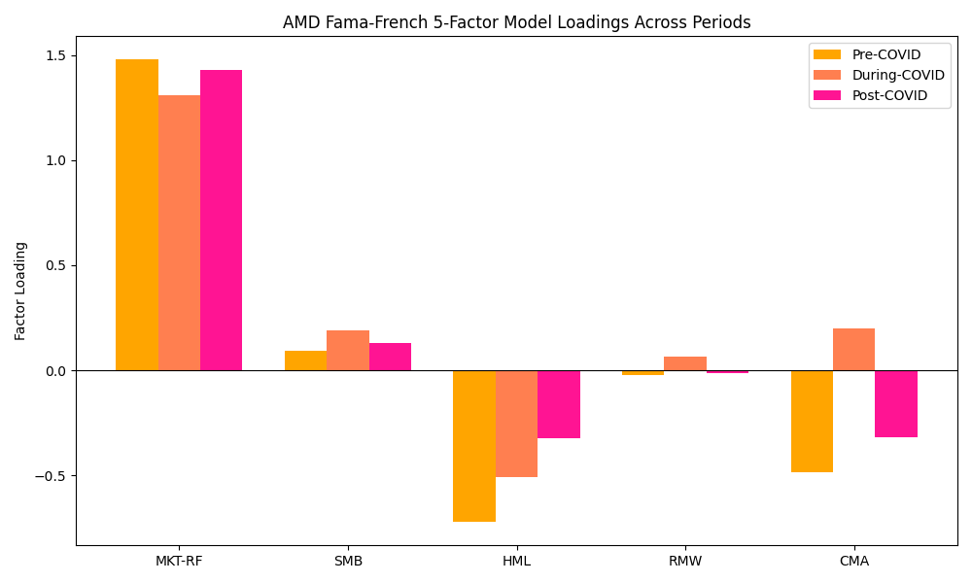  
Figure 1

AMD was extremely market-sensitive before COVID but became more stable afterward.

* The SMB indicates that AMD behaved more like a large-cap stock, especially before and during Covid. After Covid, it slightly moved toward small-cap characteristics.
* The HML indicates AMD acted like a growth stock (negative loading on value factor) the entire time.
* The RMW indicates AMD’s profitability story improved post-Covid.
* The CMA indicates AMD started behaving more like an aggressive investor post-COVID (taking more investment risks)

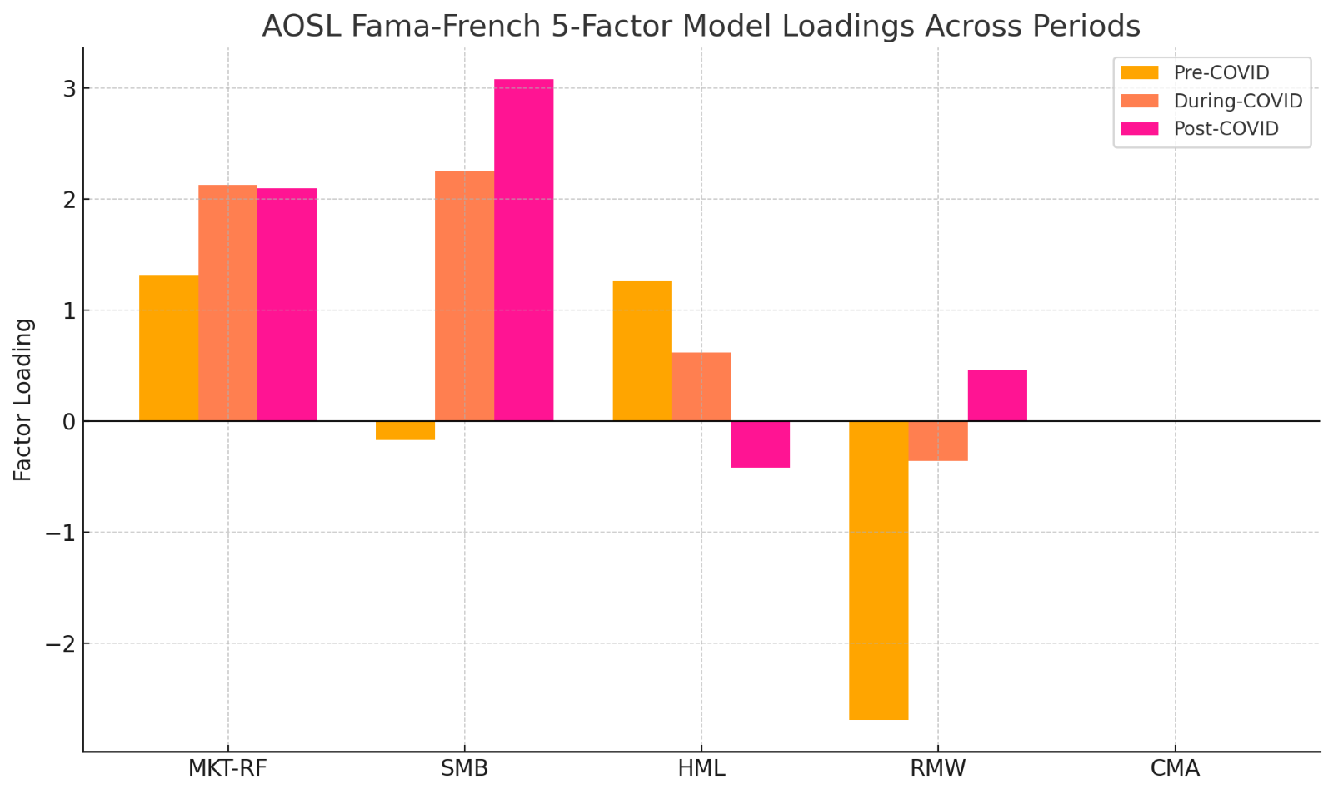  
Figure 2

AOSL is less sensitive to the overall market compared to AMD.

* AOSL behaved very much like a small-cap stock, particularly post-COVID as indicated by the SMB
* The HML indicates initially value-leaning but shifts toward growth characteristics after COVID.
* The RMW indicates Profitability characteristics improved modestly post-COVID.
* The CMA indicates AOSL became less aggressively investing post-COVID.

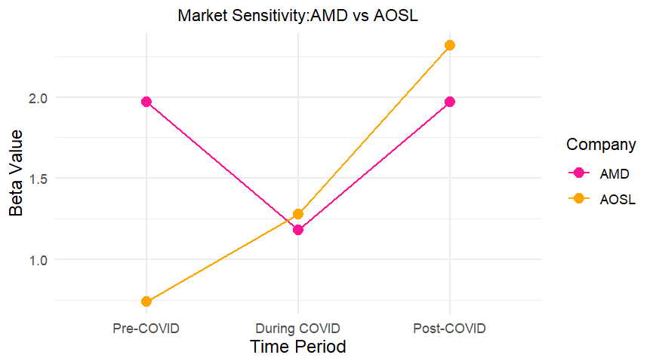  
Figure 3

**AMD**

* Pre-COVID has a high beta of ~2.0, which drops to ~1.2 during COVID, then rises back to ~2.0 post-COVID.
* AMD’s beta dropped significantly during COVID, indicating reduced sensitivity and potentially greater stability amid market uncertainty.

**AOSL**

* Pre-COVID has a beta of ~0.8, which rises to ~1.25 during COVID and jumps further to ~2.3 post-COVID.
* AOSL's beta steadily increased, highlighting growing market sensitivity and supporting the hypothesis that smaller-cap firms become more volatile during and after market shocks.

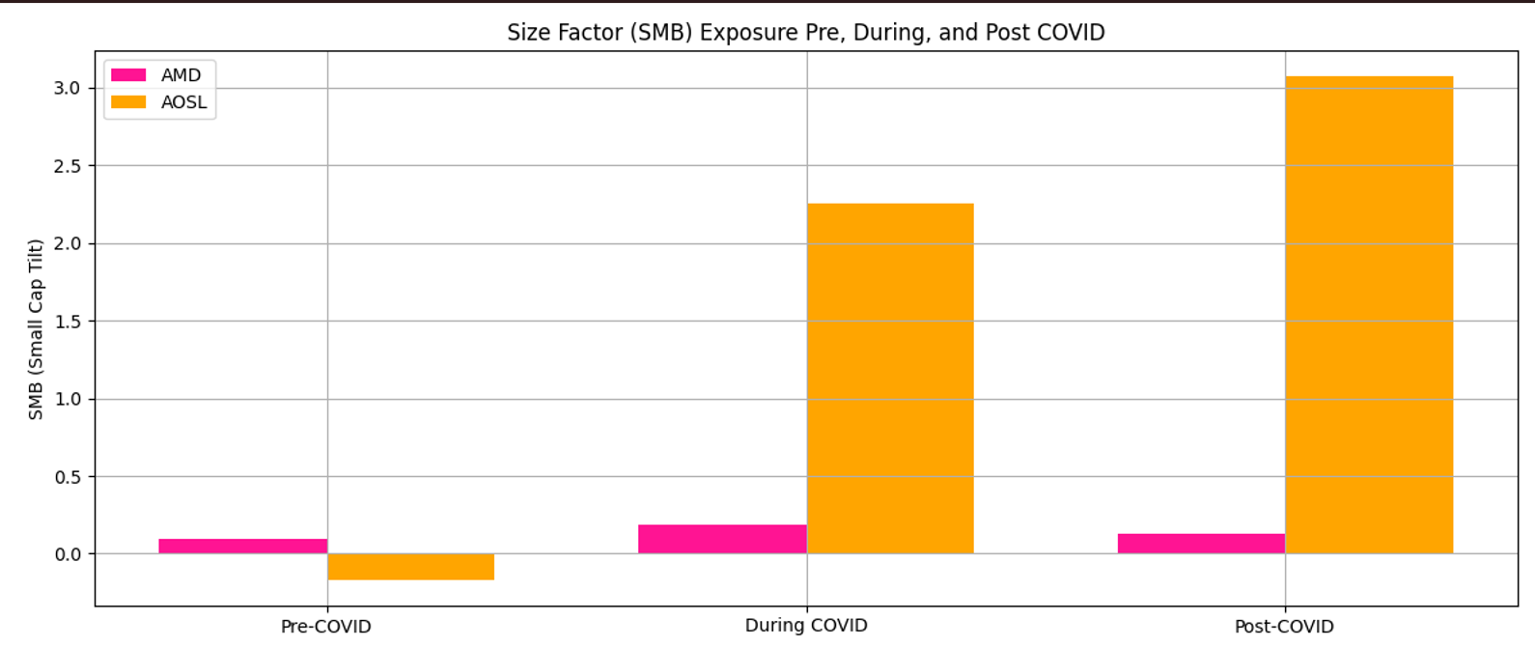  
Figure 4

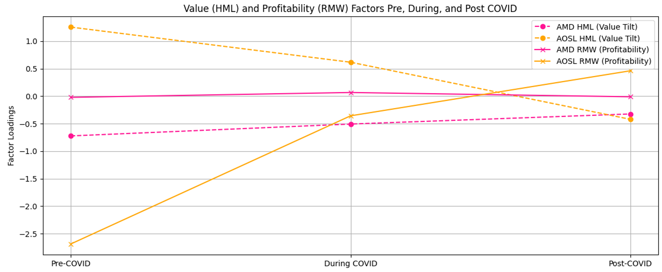  
Figure 5

As we can see, small AI-adopting firms like AOSL outperformed larger ones like AMD in the face of the COVID-19 shock.

AOSL’s high positive SMB exposure, HML, and recovery in profitability (RMW) post-COVID positioned it to capture stronger returns during the market rebound.

AMD, as a large-cap, growth-focused firm, remained more stable but did not benefit as dramatically from the crisis recovery factors.

This can be due to multiple reasons. One reason we can predict is that small-cap companies like AOSL having a **structural advantage:**

* Their smaller size allowed for faster decision-making and quicker pivoting to new technologies and supply chain adjustments.
* Their early adoption and integration of AI, particularly for optimizing operations, manufacturing processes, and predictive analytics, positioned them to be more resilient and opportunistic during volatile times.

Meanwhile, larger firms like AMD, while leaders in AI at the chip design and infrastructure level, faced greater inertia:

* Their global scale and more complex operations made them slower to adjust to pandemic disruptions.
* Larger firms often have existing legacy systems that make it harder to fully leverage AI across all business units quickly during crisis.

**PART 2: CAMP and Fama French Model results for all 6 companies:**

Although for our case study we mainly focus on AOSL vs AMD, we can still look at results of all our company results from CAPM and FF5FM:

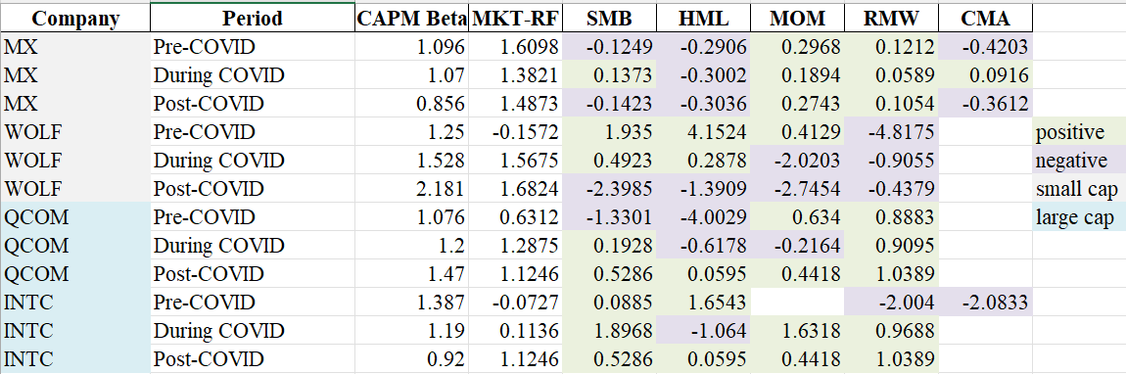Table 1

Based on these results we can still gain a couple of insights:

*CAPM Beta (Market Sensitivity)*

1. MX: Beta remained stable (~1.07), indicating moderate market sensitivity.
2. WOLF: Beta increased from 1.25 (pre) to 2.18 (post), showing high and rising sensitivity.
3. QCOM & INTC: Moderate increase in beta, but lower than WOLF in post-COVID.

We can conclude small-cap stocks showed higher or increasing market sensitivity, especially WOLF.

*SMB Factor (Size Premium):*

* MX: SMB turned positive during COVID (+0.1373) from negative SMB during pre-covid.
* WOLF: SMB was strongly positive pre-Covid but became highly negative during covid.
* QCOM & INTC: SMB mostly positive during/post, implying small-cap underperformance.

SMB indicates small-cap did not consistently outperform large-cap, especially for WOLF even though for MX it did.

*HML*

* MX: Pre-COVID: –0.2906 (growth tilt) to –0.3002 (still growth) during covid and post-covid (–0.3036 (growth))
* WOLF: HML was strongly positive pre-COVID (+4.1524, value tilt), but flipped to negative post-COVID (–1.3909), showing a shift to growth.
* QCOM: HML moved from strongly negative pre-COVID (–4.0029, growth tilt) to nearly neutral post-COVID (+0.0595), indicating a softening growth tilt.
* INTC: HML shifted from positive pre-COVID (+1.6543, value tilt) to negative during COVID (–1.064, growth tilt), then returned to near neutral (+0.0595).

Hence, we can conclude there has been consistent strong growth tilt small cap companies during and post-covid.

**4. Conclusion**

This study examined the stock performance of AI-adopting semiconductor firms across three distinct periods: pre-COVID, during COVID, and post-COVID. We focused on comparing large-cap and small-cap companies, evaluating their resilience and risk-return dynamics using CAPM and various Fama-French factor models. By analyzing the 6 firms, we explored how firm size and technological integration influenced financial outcomes during macroeconomic disruptions.

Our findings indicate that large-cap AI-adopting firms exhibited greater resilience during the pandemic, with lower volatility and more stable returns compared to their small-cap counterparts. Small-cap firms, while offering potentially higher returns, experienced significantly higher volatility and market sensitivity. Across the periods, we observed that beta values for most firms declined during COVID-19, reflecting a general reduction in systematic risk amid heightened uncertainty. Size factor (SMB) exposures shifted dynamically, particularly for small-cap firms, suggesting changing investor perceptions of risk and opportunity.

This research highlights the importance of considering both firm size and technological adoption when evaluating investment opportunities in AI-driven sectors. Large-cap firms may appeal to investors seeking stability, whereas small-cap firms may attract those willing to embrace greater risk for potential outsized gains. The interaction between macroeconomic events and technological shifts, such as AI integration, creates differentiated risk profiles that traditional models alone may not fully capture.

**Potential extensions of this study** could include expanding the sample to incorporate firms from other industries actively adopting AI, such as healthcare, finance, or consumer goods. Additionally, future research could refine the classification of AI-adopting firms by incorporating third-party AI innovation indices or patent databases. Applying machine learning techniques to identify firm clusters based on AI integration depth could further enrich the analysis. A longer post-COVID observation period would also help assess the sustainability of performance trends identified in this study.

In conclusion, our research contributes to the growing literature on technology adoption and financial performance under crisis conditions.

*References:*

Ho, Linh & Gan, Christopher & Jin, Shan & Le, Bryan. (2022). Artificial Intelligence and Firm Performance: Does Machine Intelligence Shield Firms from Risks?. Journal of Risk and Financial Management. 15. 302. 10.3390/jrfm15070302.